1. Write a C++ Program to print "Hello, World!"

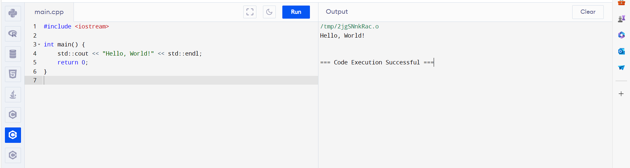

2. Write a C++ Program to Print Number Entered by User

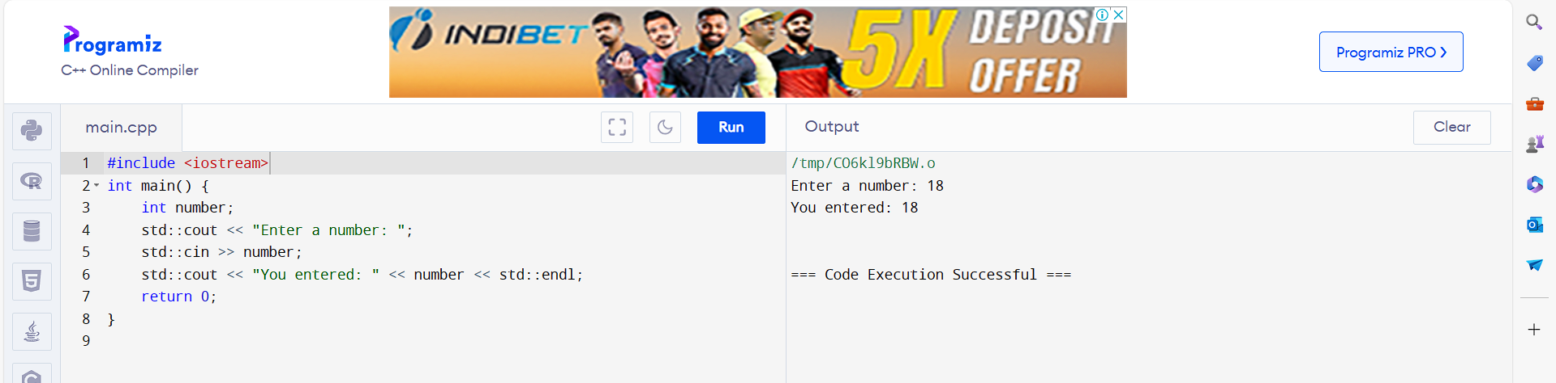

3. Write a C++ Program to Add Two Numbers

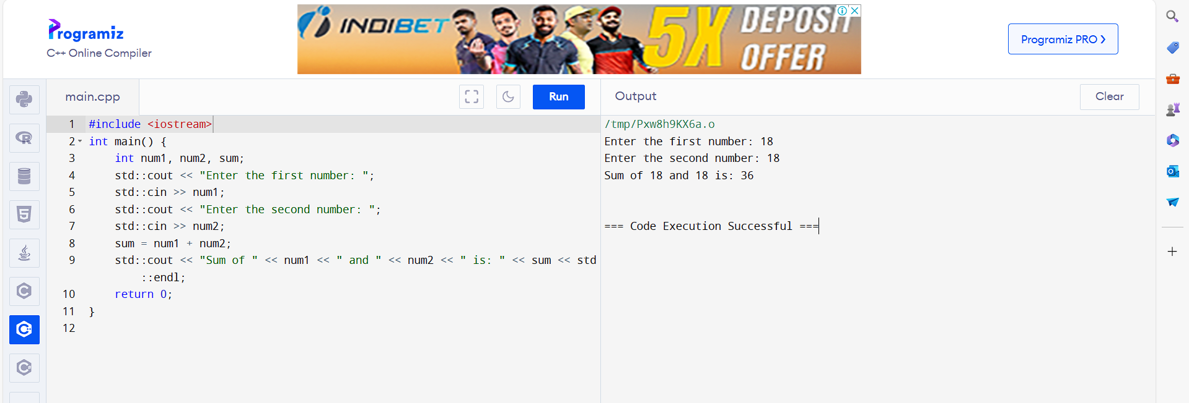

4. Write a C++ Program to Find Quotient and Remainder

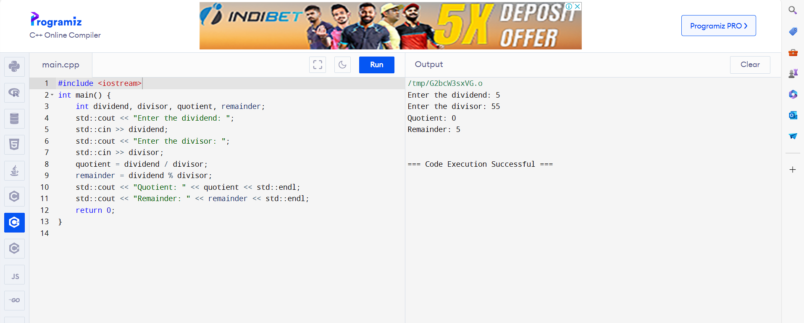

5. Write a C++ Program to Find Size of int, float, double and char in Your System

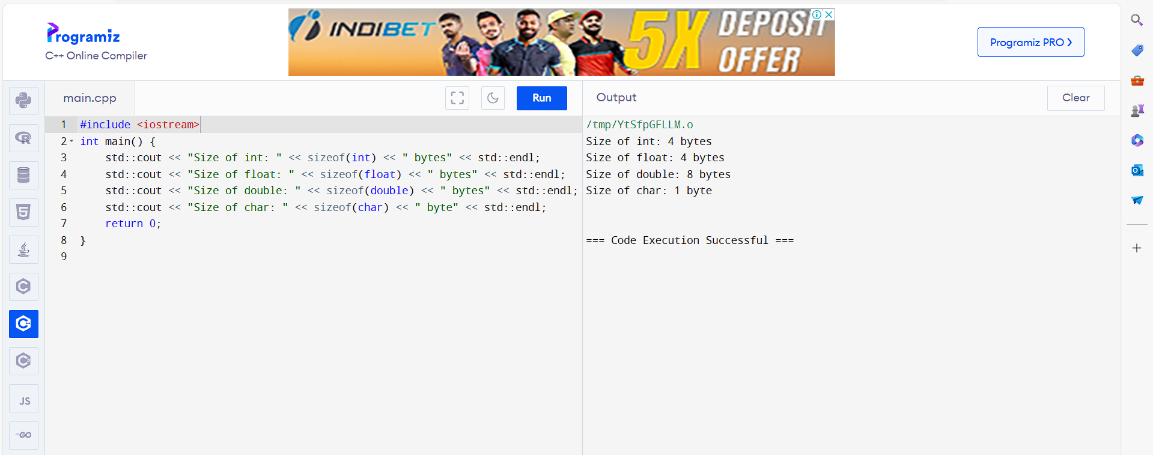

6. Write a C++ Program to Swap Two Numbers

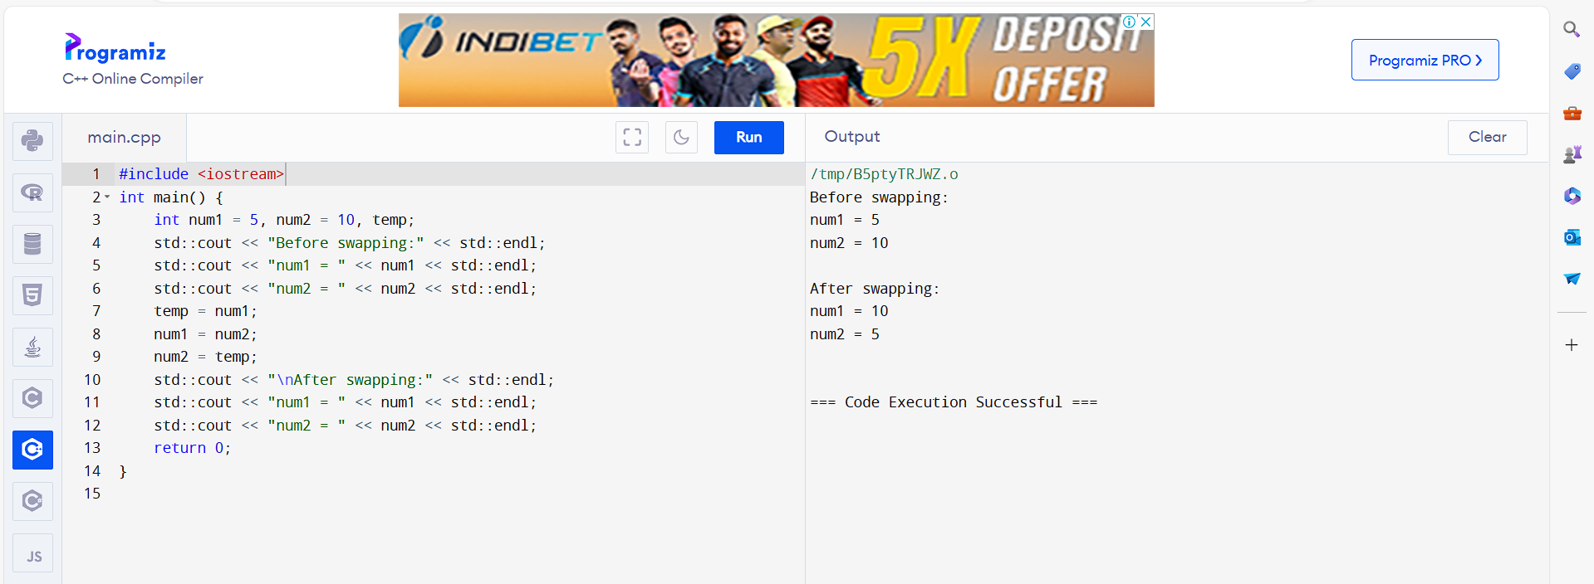

7. Write a C++ Program to Check Whether Number is Even or Odd

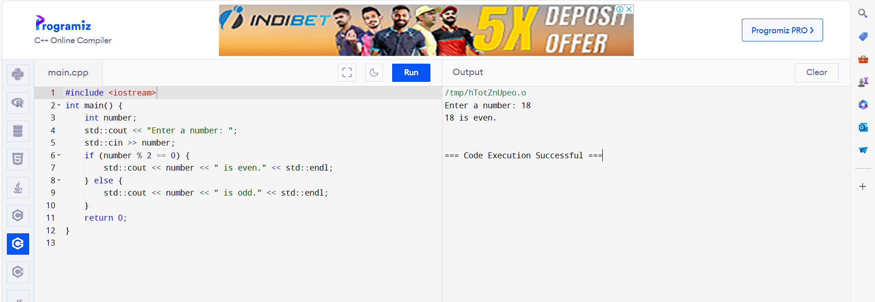

8. Write a C++ Program to Check Whether a character is Vowel or Consonant.

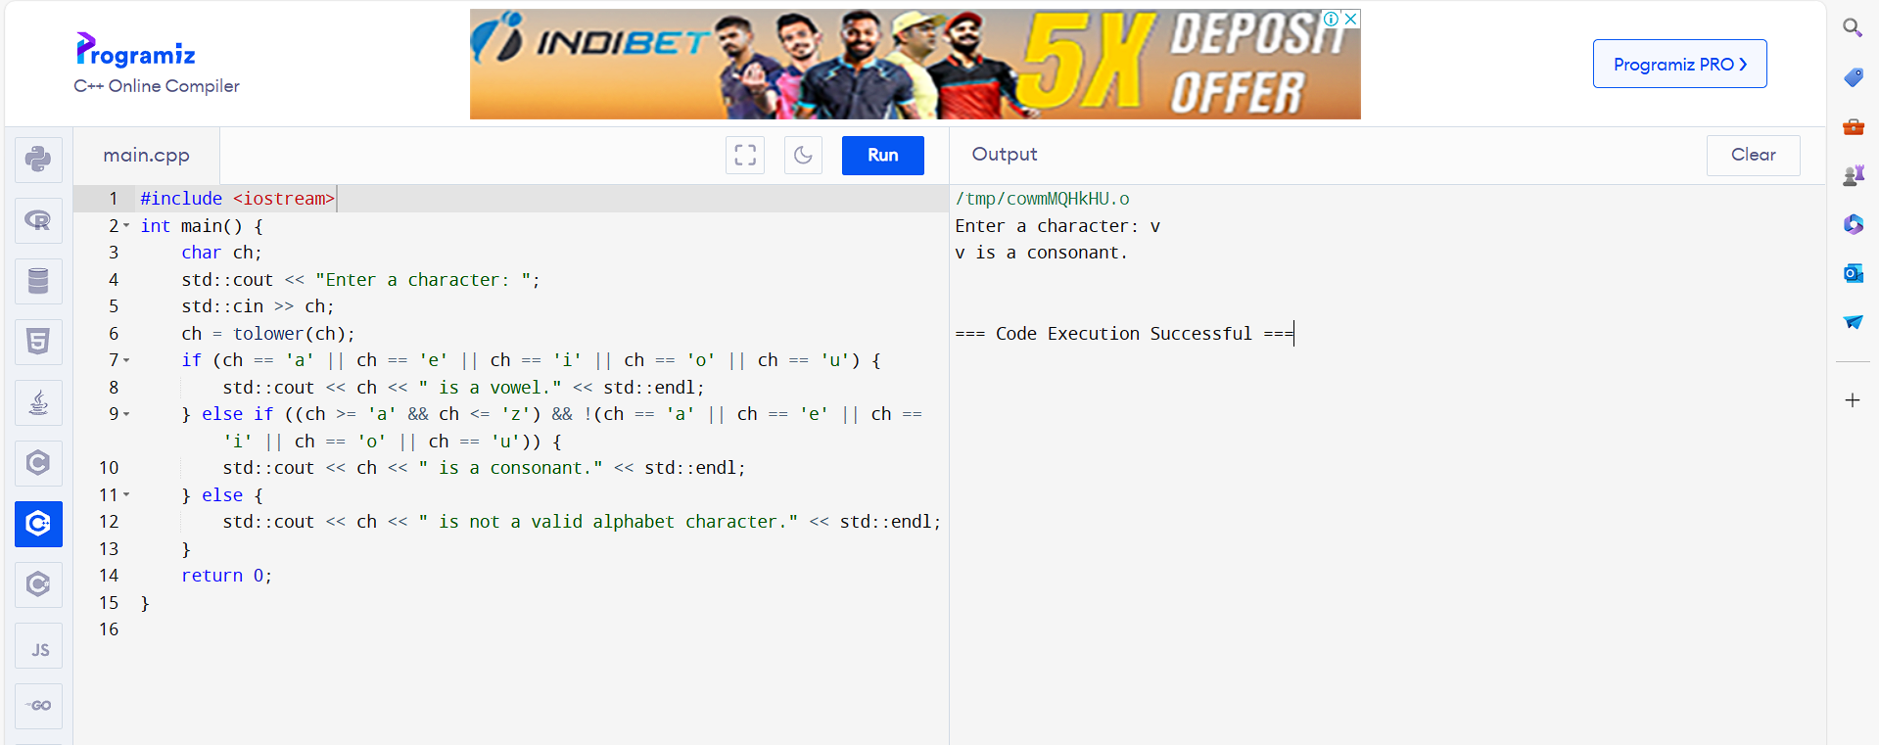

9. Write a C++ Program to Find Largest Number Among Three Numbers

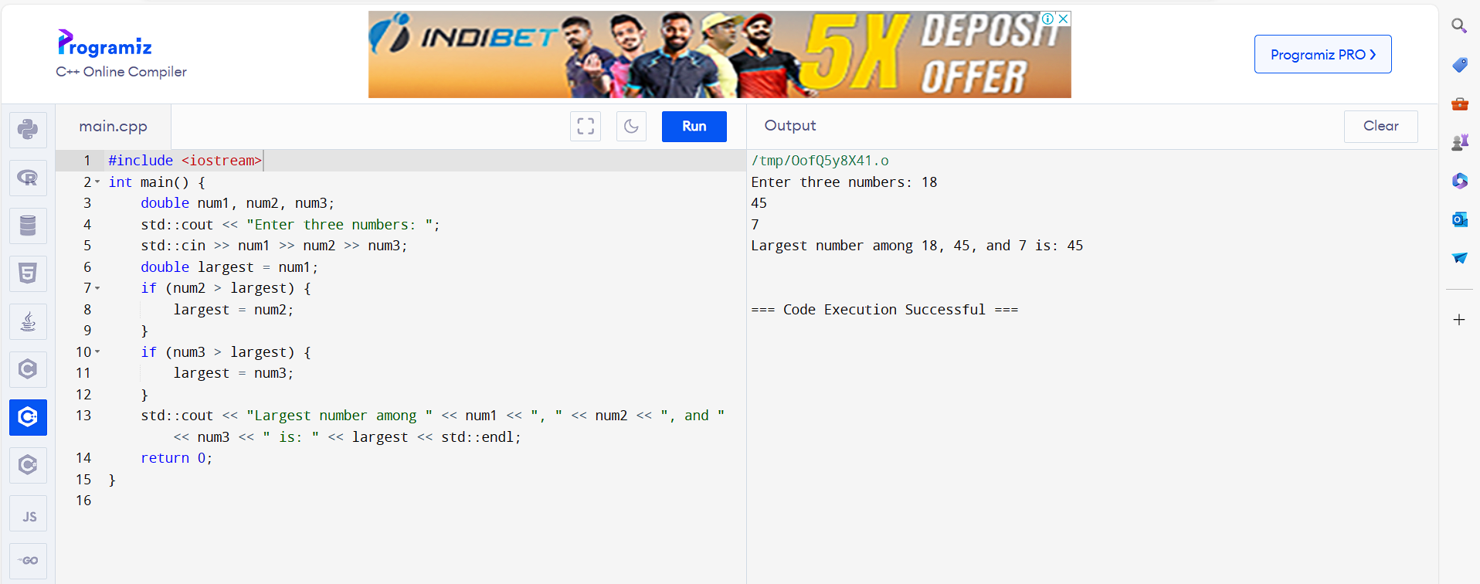

10. Write a C++ Program to Find All Roots of a Quadratic Equation

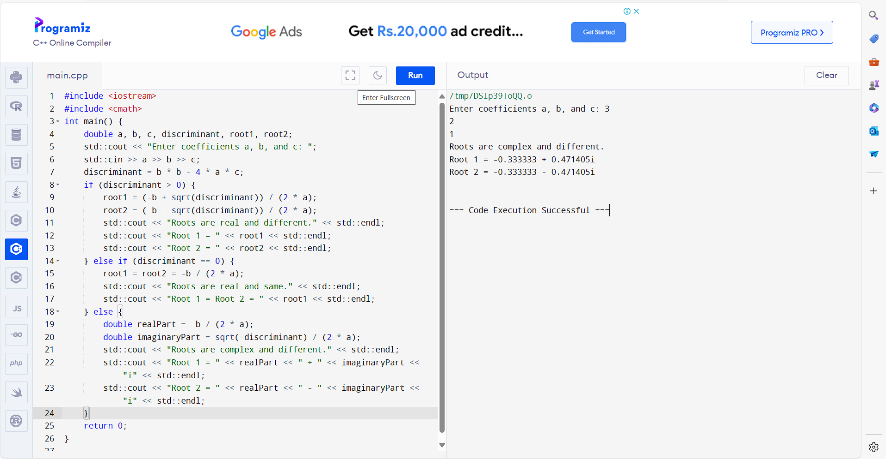

11. Write a C++ Program to Calculate Sum of Natural Numbers

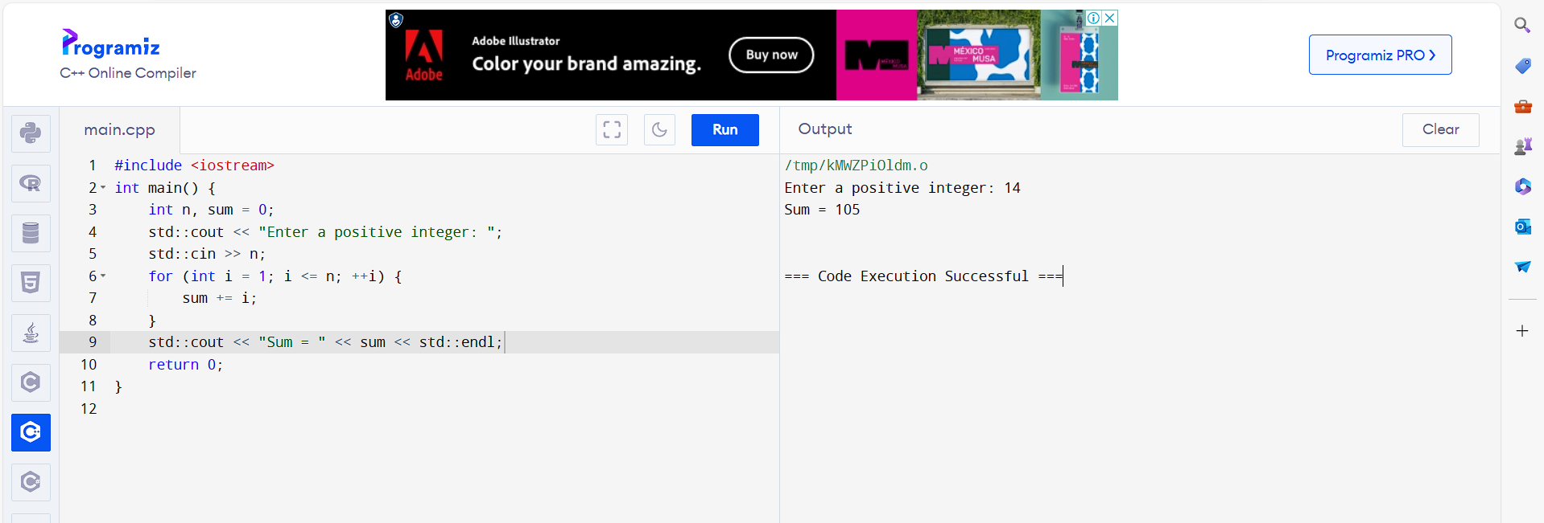

12. Write a C++ Program to Check Leap Year

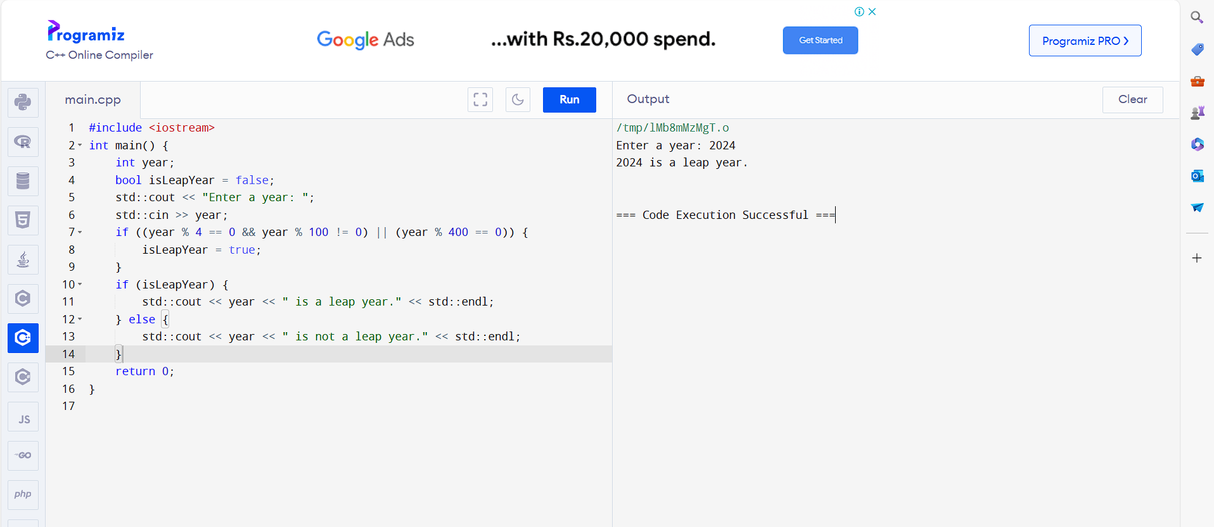

13. Write a C++ Program to Find Factorial

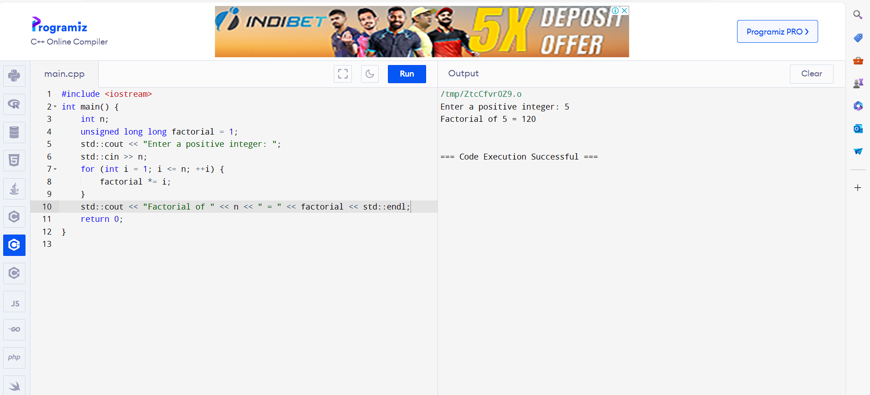

14. Write a C++ Program to Generate Multiplication Table

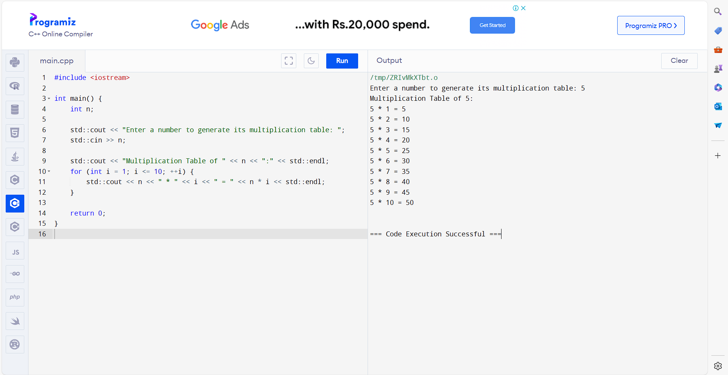

15. Write a C++ Program to Display Fibonacci Series

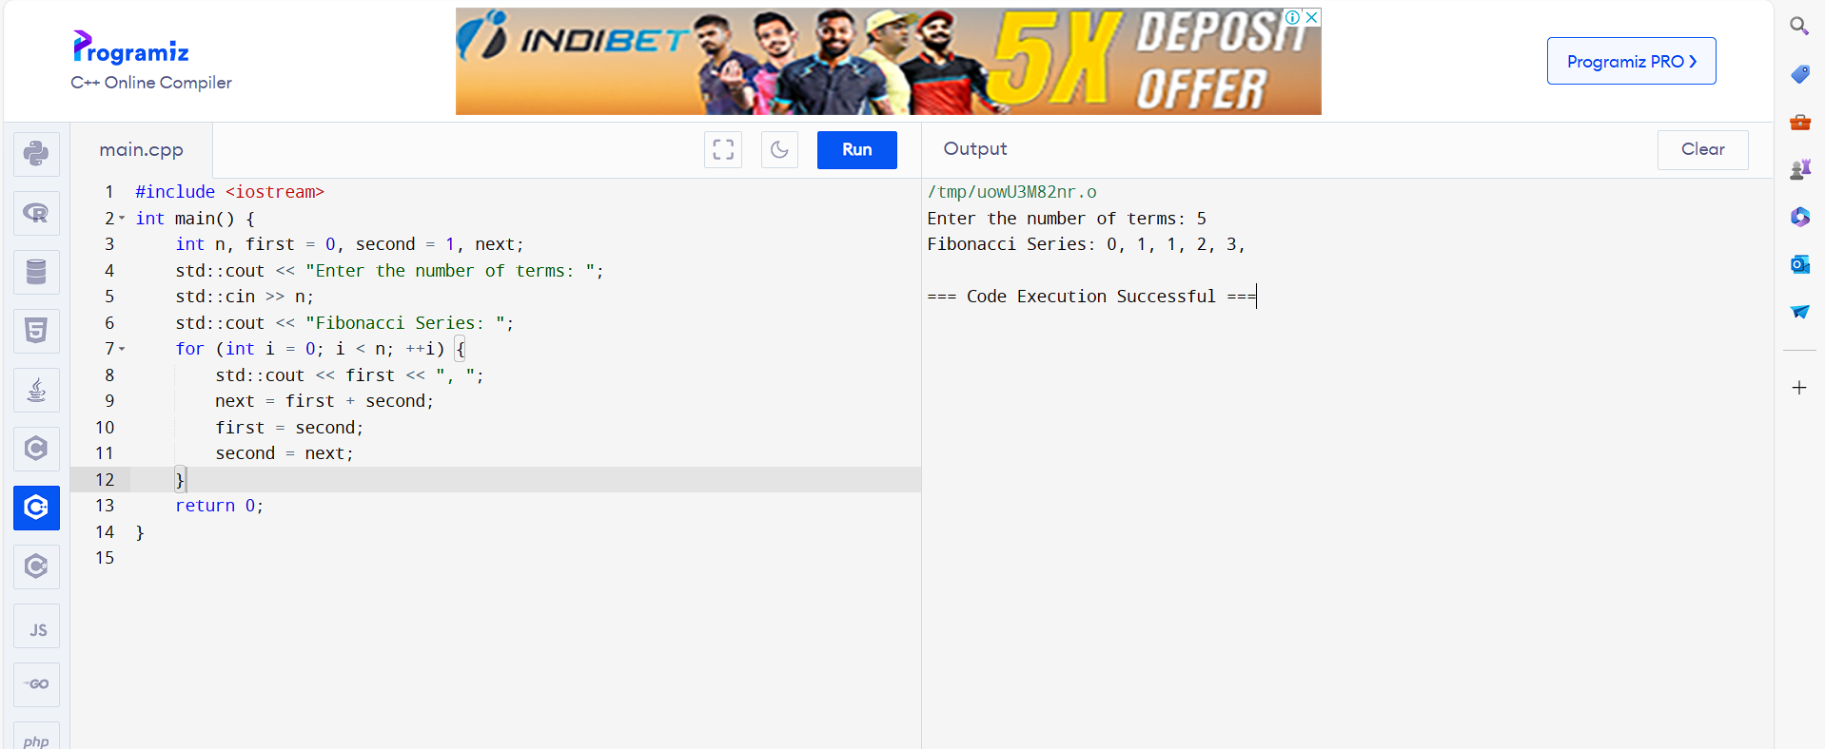

16. Write a C++ Program to Find GCD

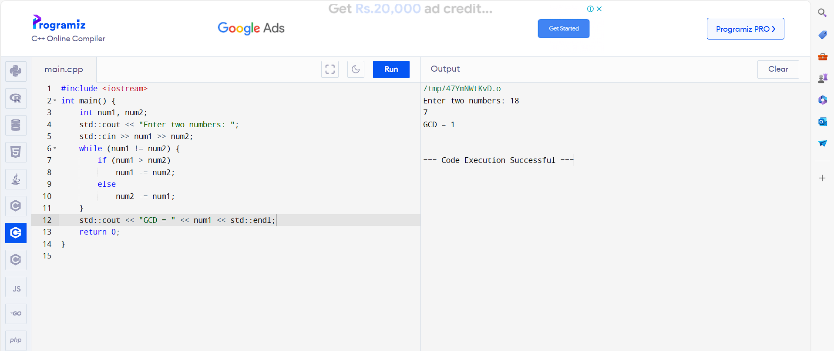

17. Write a C++ Program to Find LCM

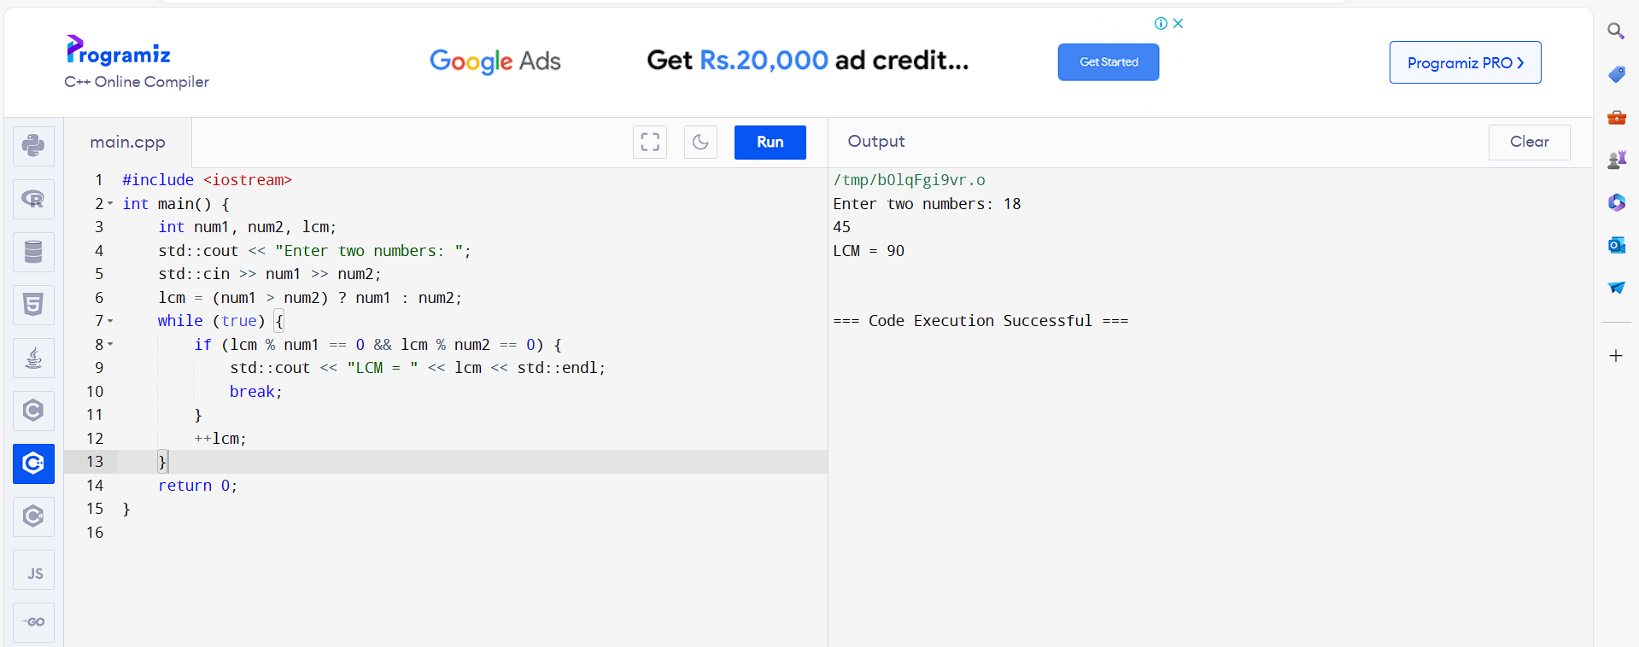

18. Write a C++ Program to Reverse a Number

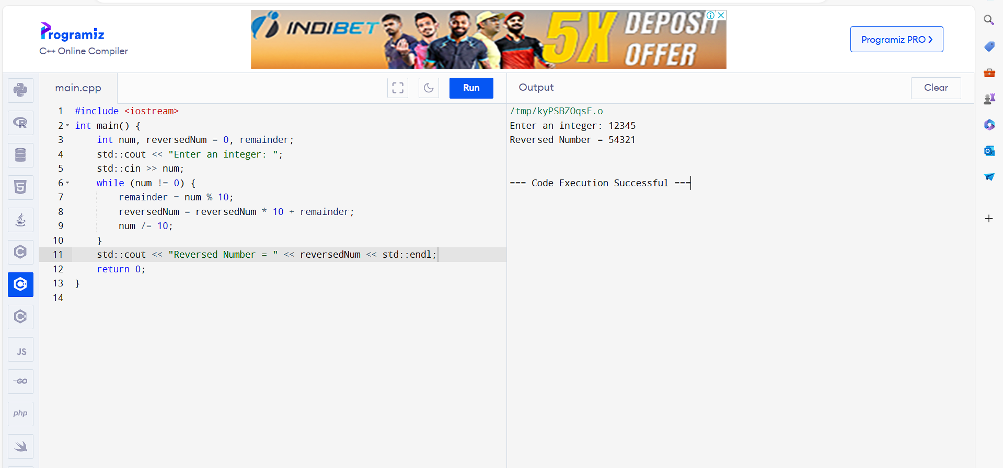

19. Write a program to read in two integers and perform the following operations on

them: addition, subtraction, multiplication, division, and modulo.

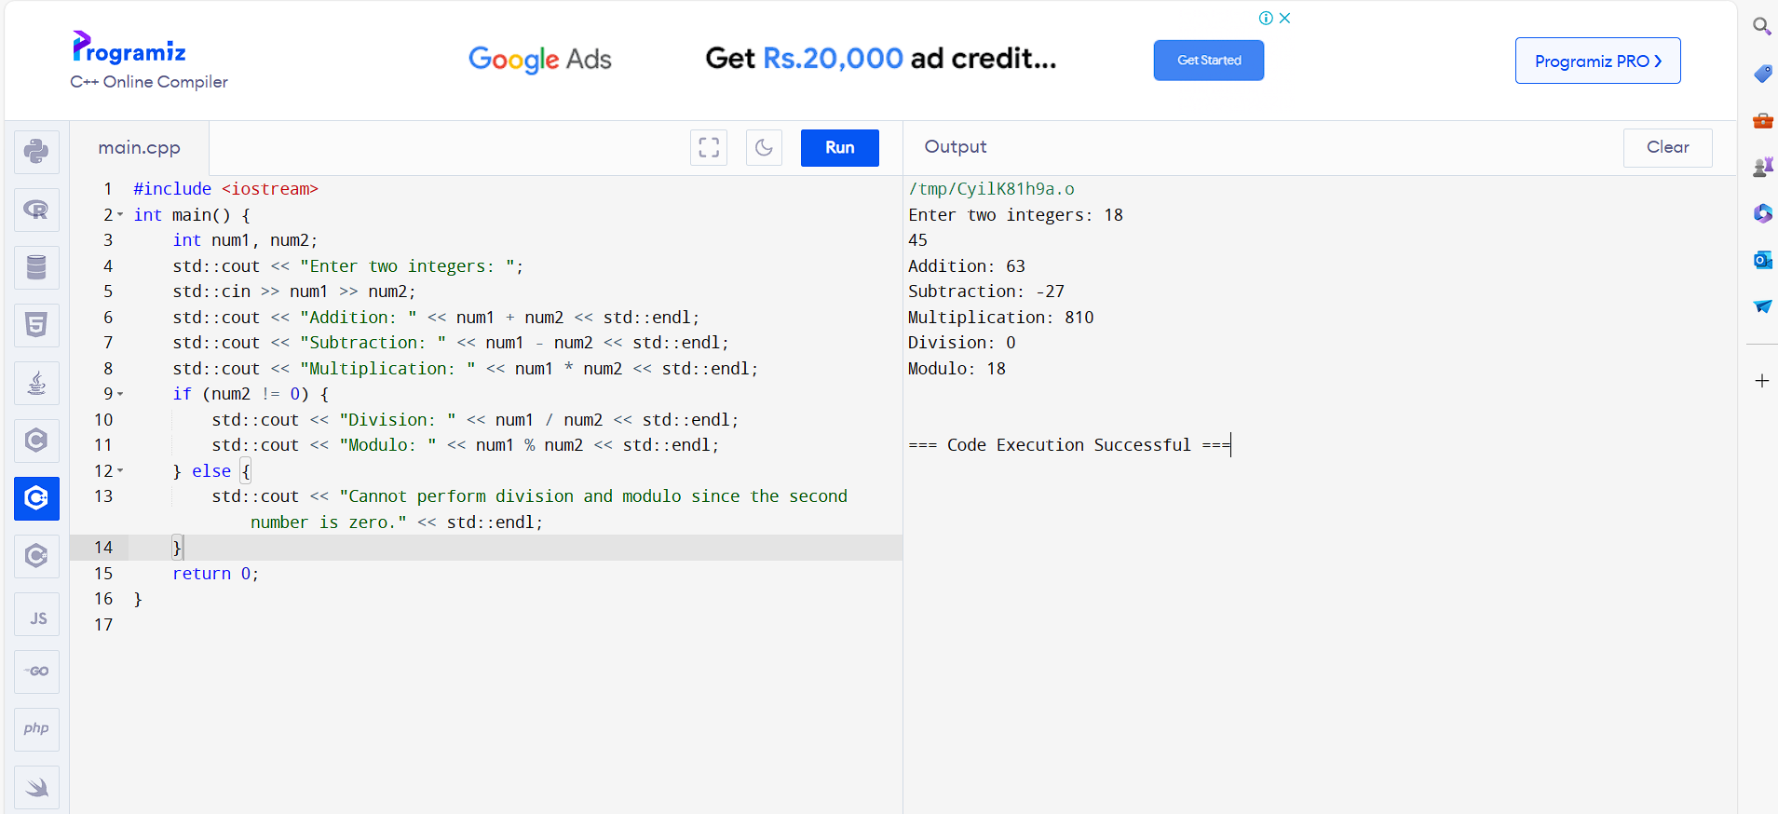

20. Write a C++ Program to determine the integer is odd or even.

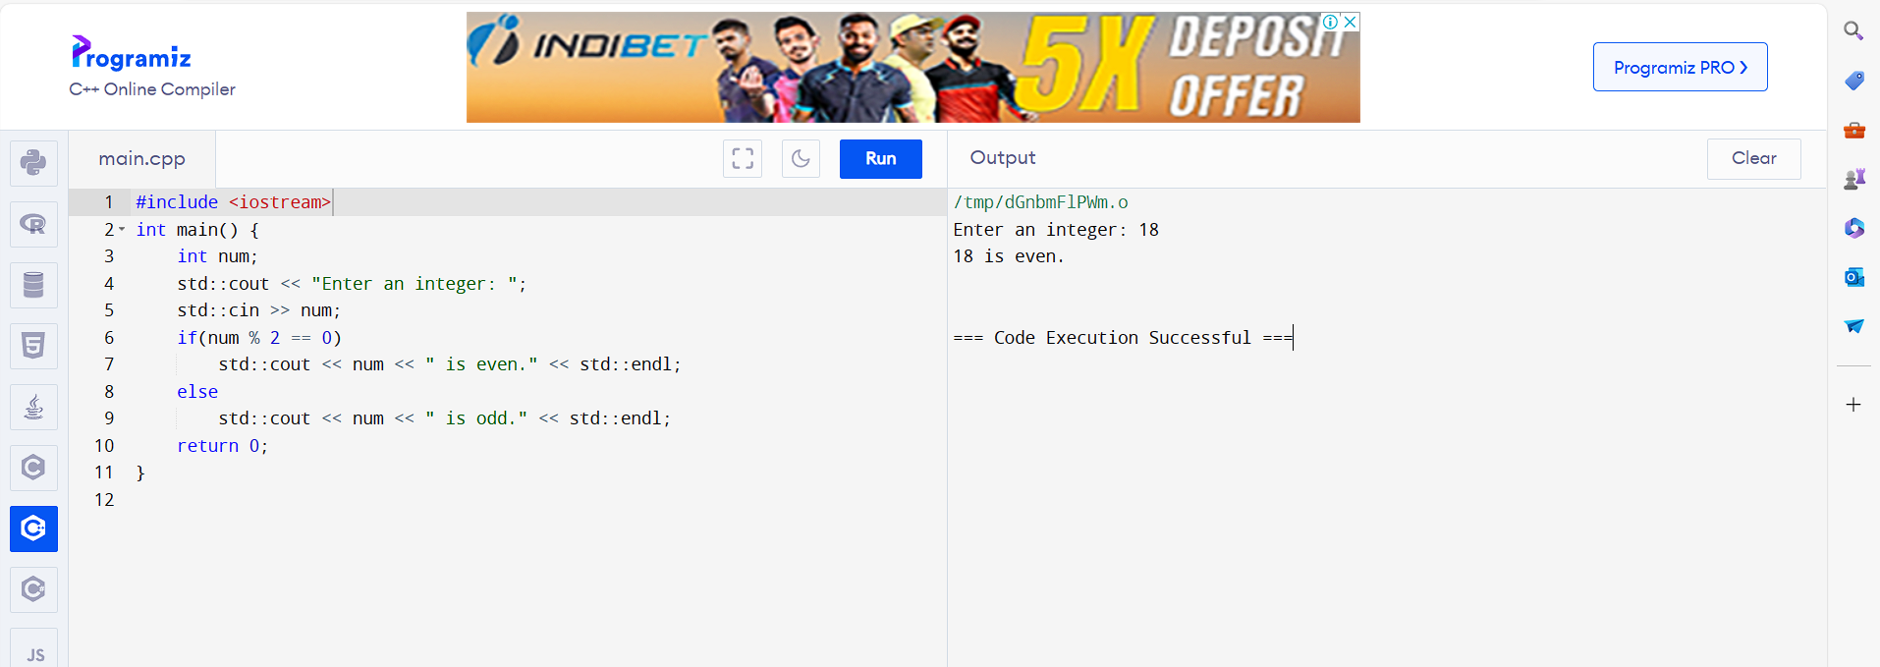

21. Write a C++ Program to compute the average of three integers

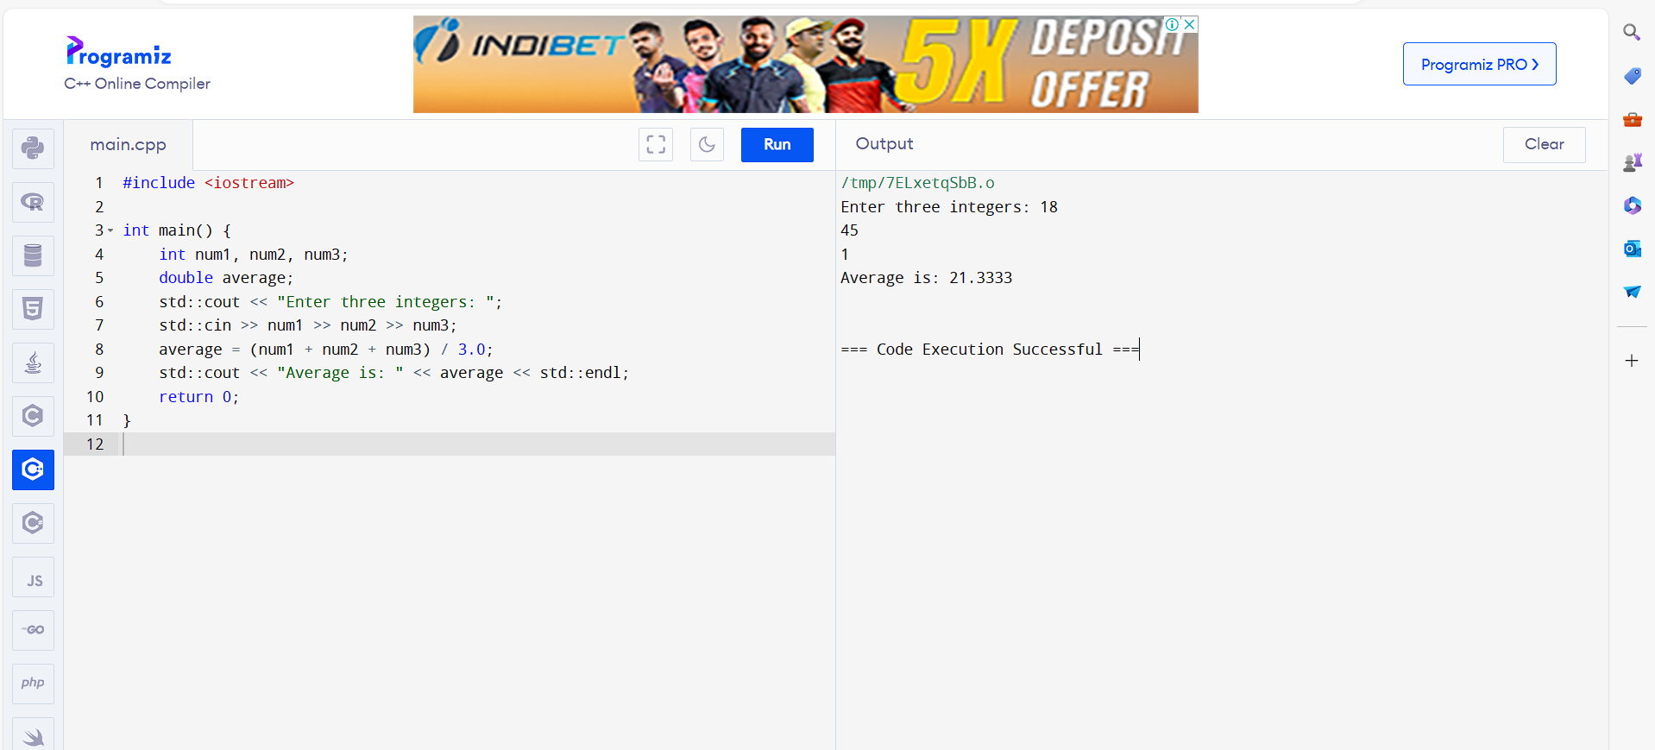

22. Write a C++ Program to check two numbers are equal or not

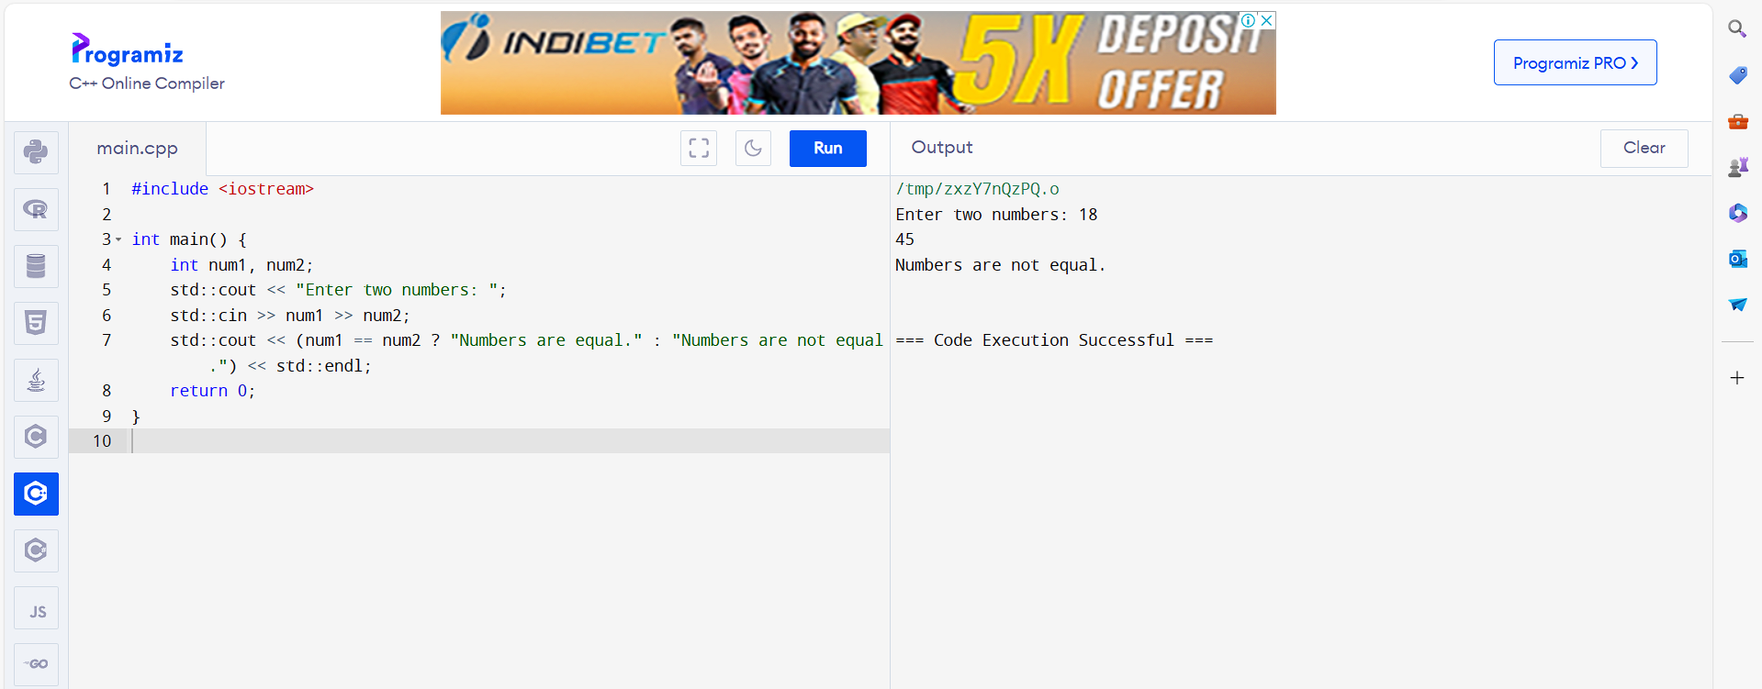

23. Write a program to read in two Floating numbers and perform the following

operations on them: addition, subtraction, multiplication, division, and modulo.

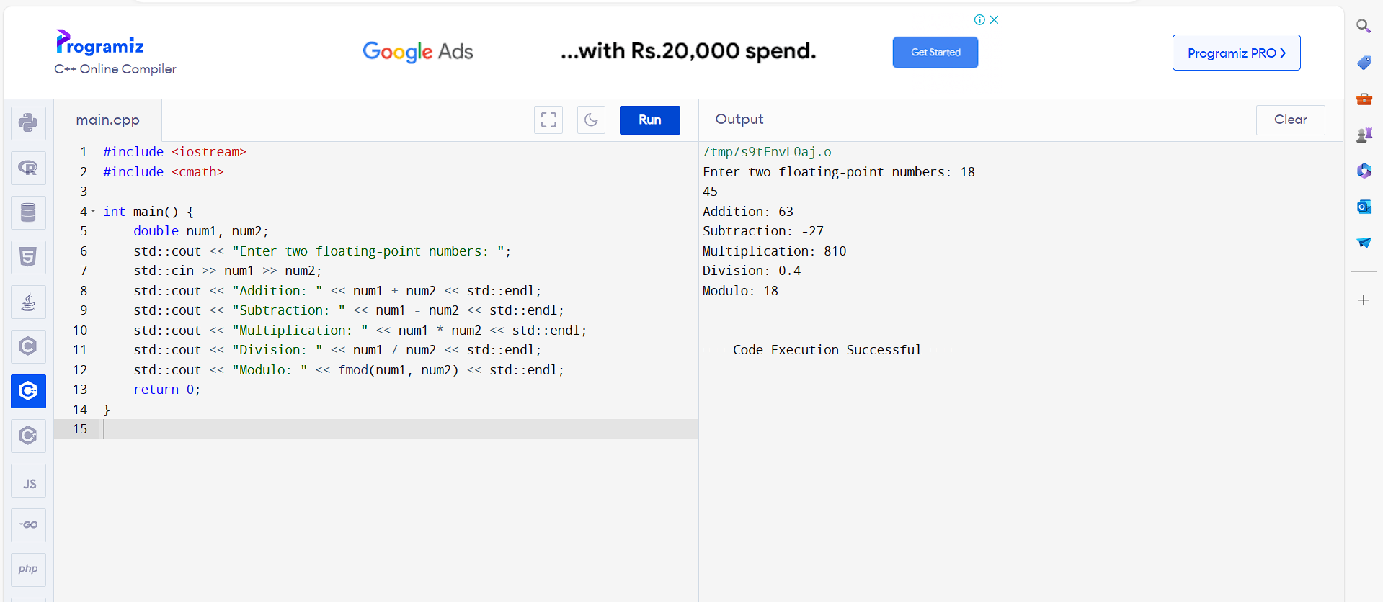

24. Write a C++ Program to check the character is a vowel or consonant

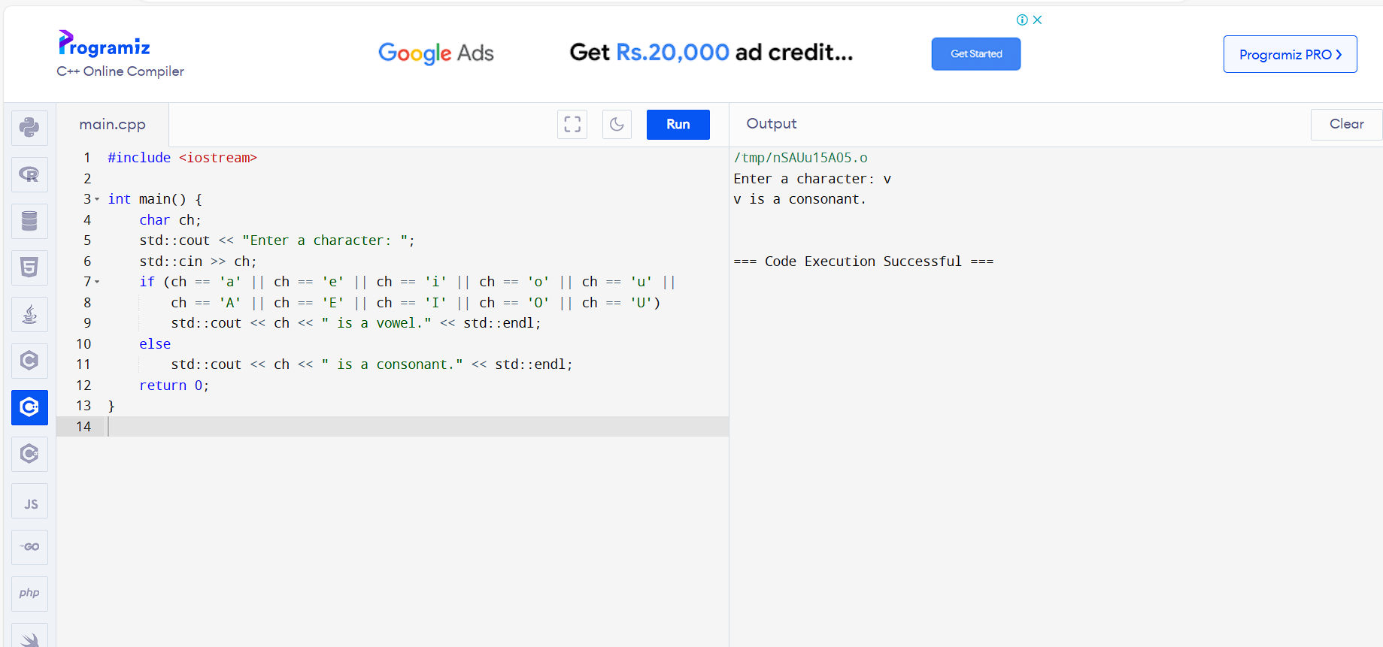

25. Write a C++ Program to check the number is positive, negative or zero

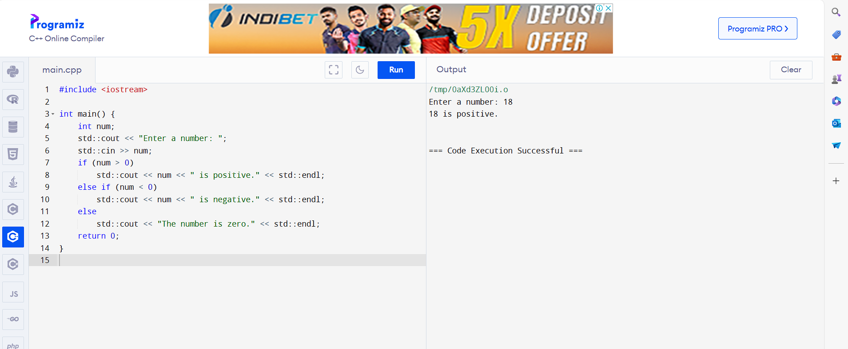

26. Write a C++ Program to determine which number is greater among two integers

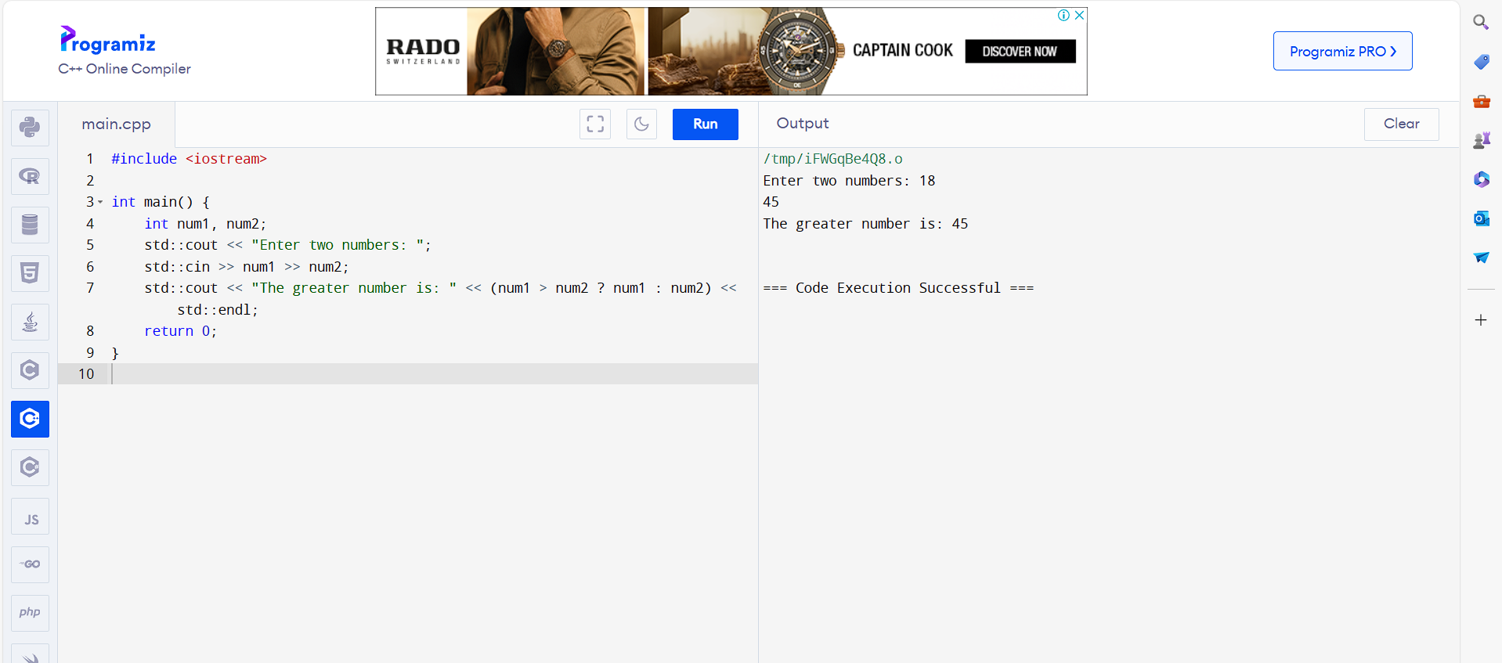

27. Write a C++ Program to read a floating-number and round it to the nearest integer

using the floor an ceil functions.

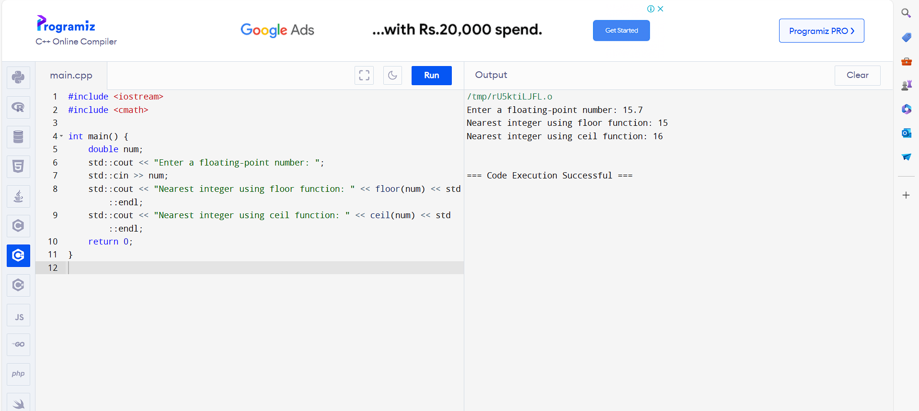

28. Write a C++ Program to swap two numbers using bitwise XOR operator

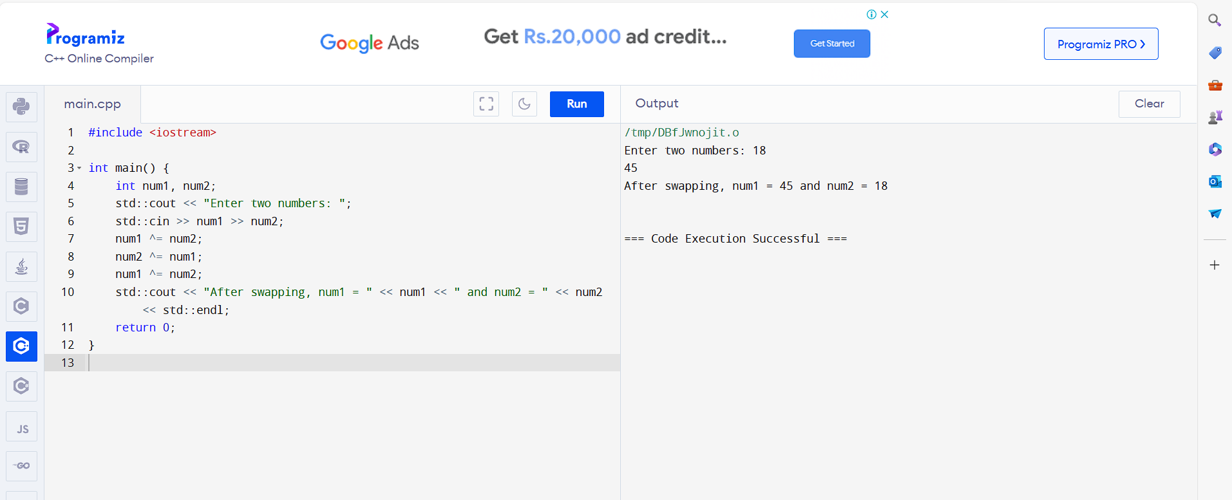

29. Write a C++ Program to find Largest among three numbers using ternary

conditional operator

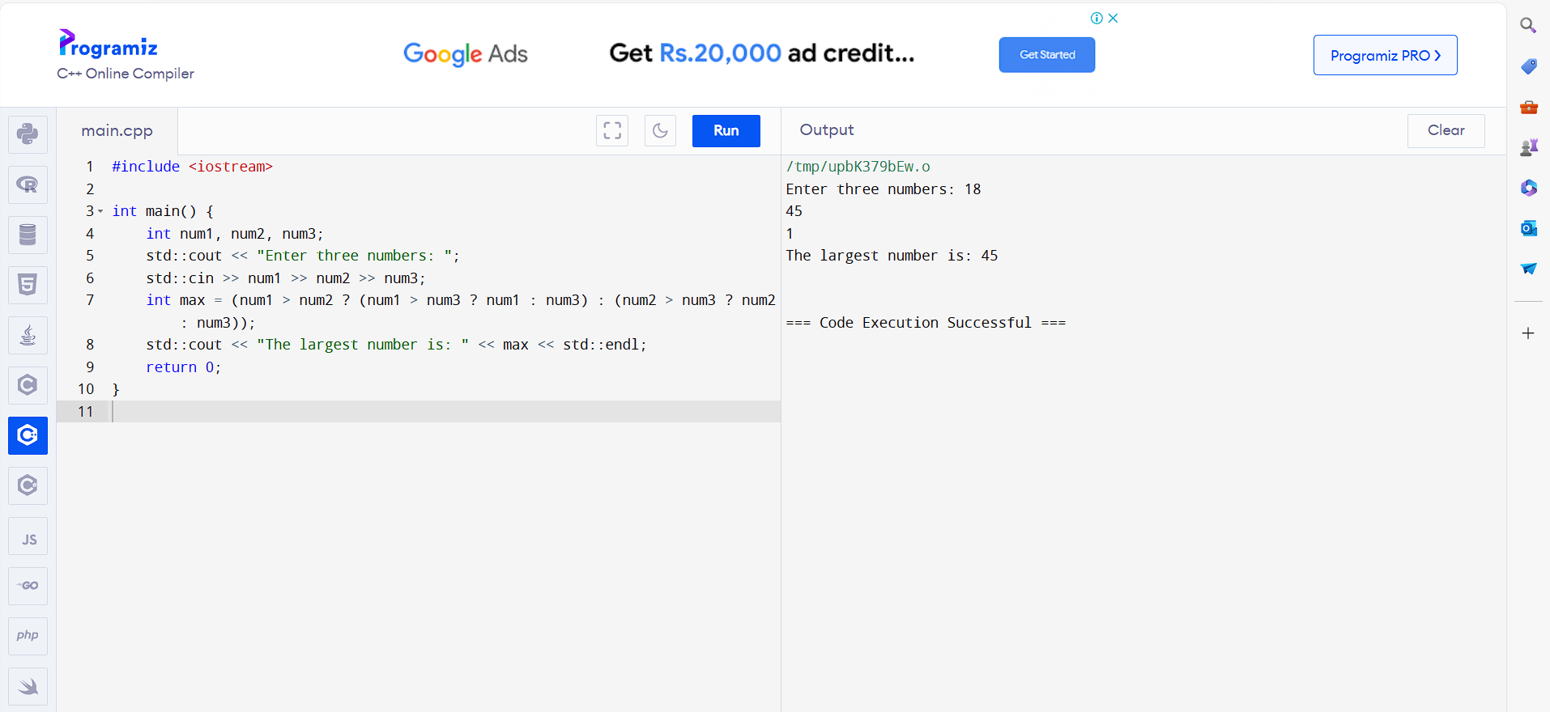

30. Write a C++ Program to check two numbers are equal or not using ternary

conditional operator

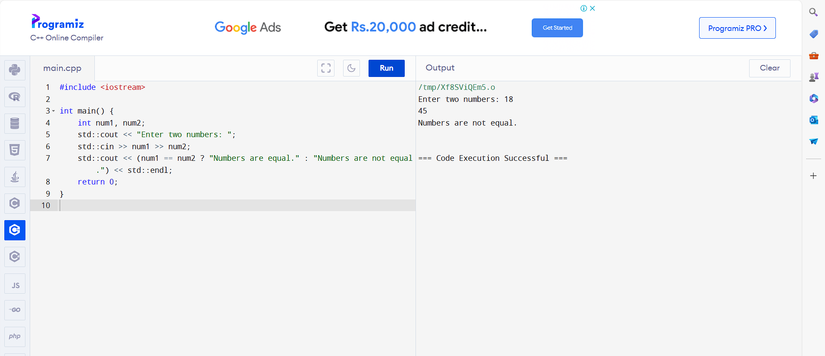

31. Write a C++ Program to check the integer is divisible by 3 or not using ternary

conditional operator

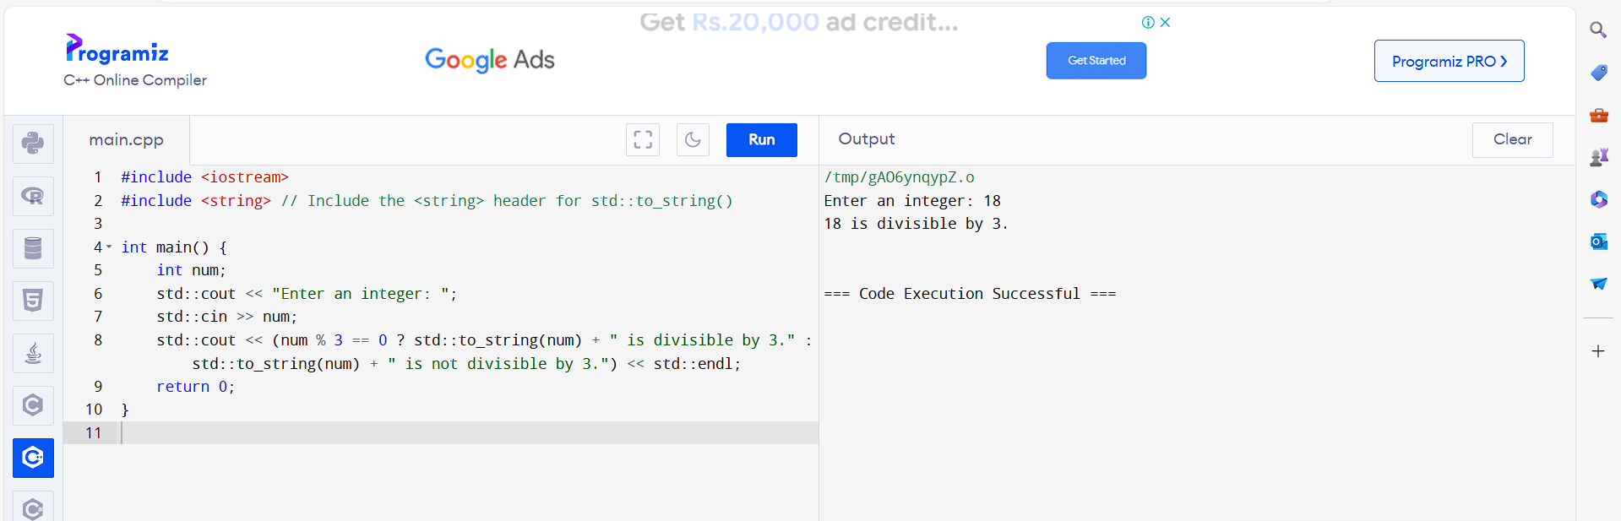

32. Write a C++ Program to print numbers from 1 to 10 using for loop

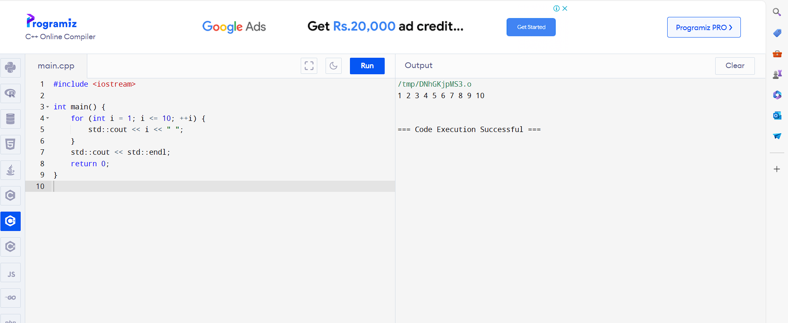

33. Write a C++ Program to find Factorial of a number using for loop

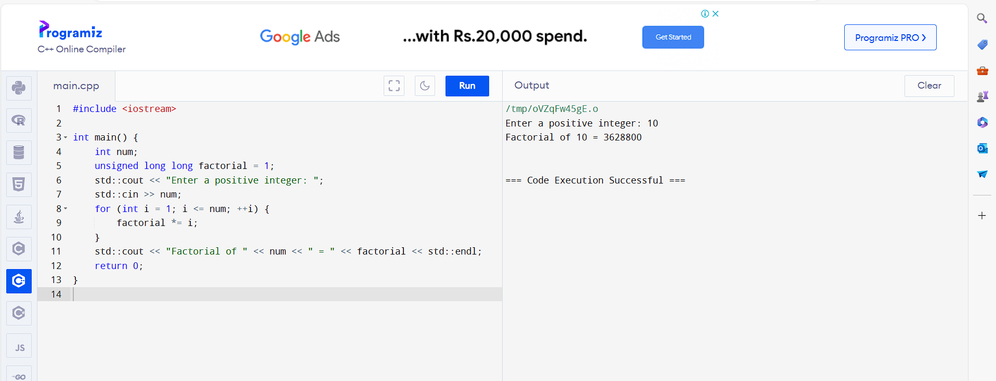

34. Write a C++ Program to Print multiplication table using for loop

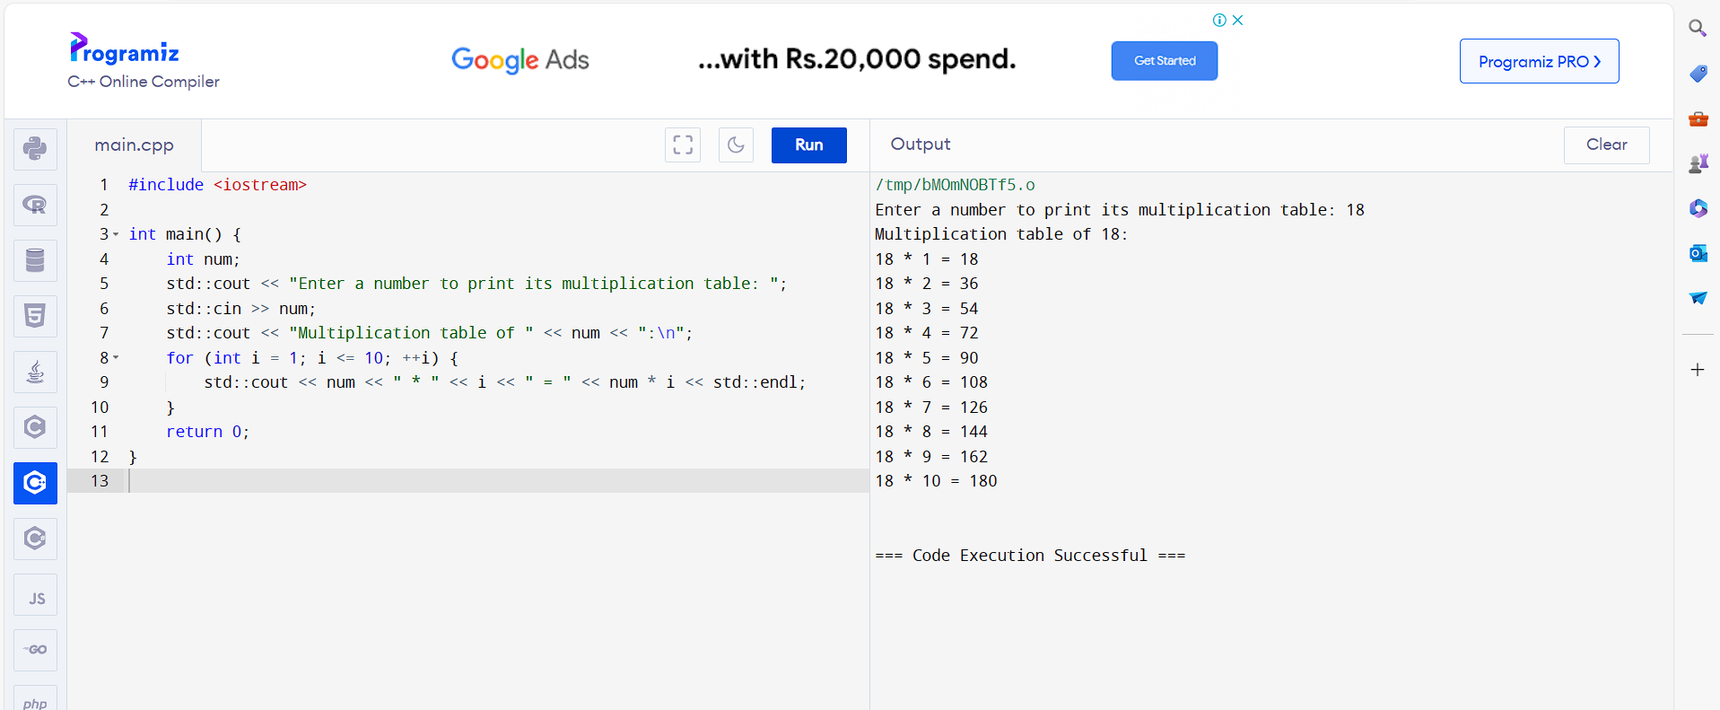

35. Write a C++ Program to Print Fibonacci series using for loop

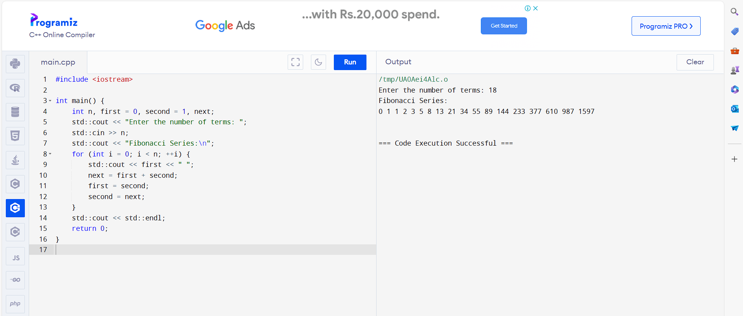

36. Write a C++ Program to find Prime number using for loop

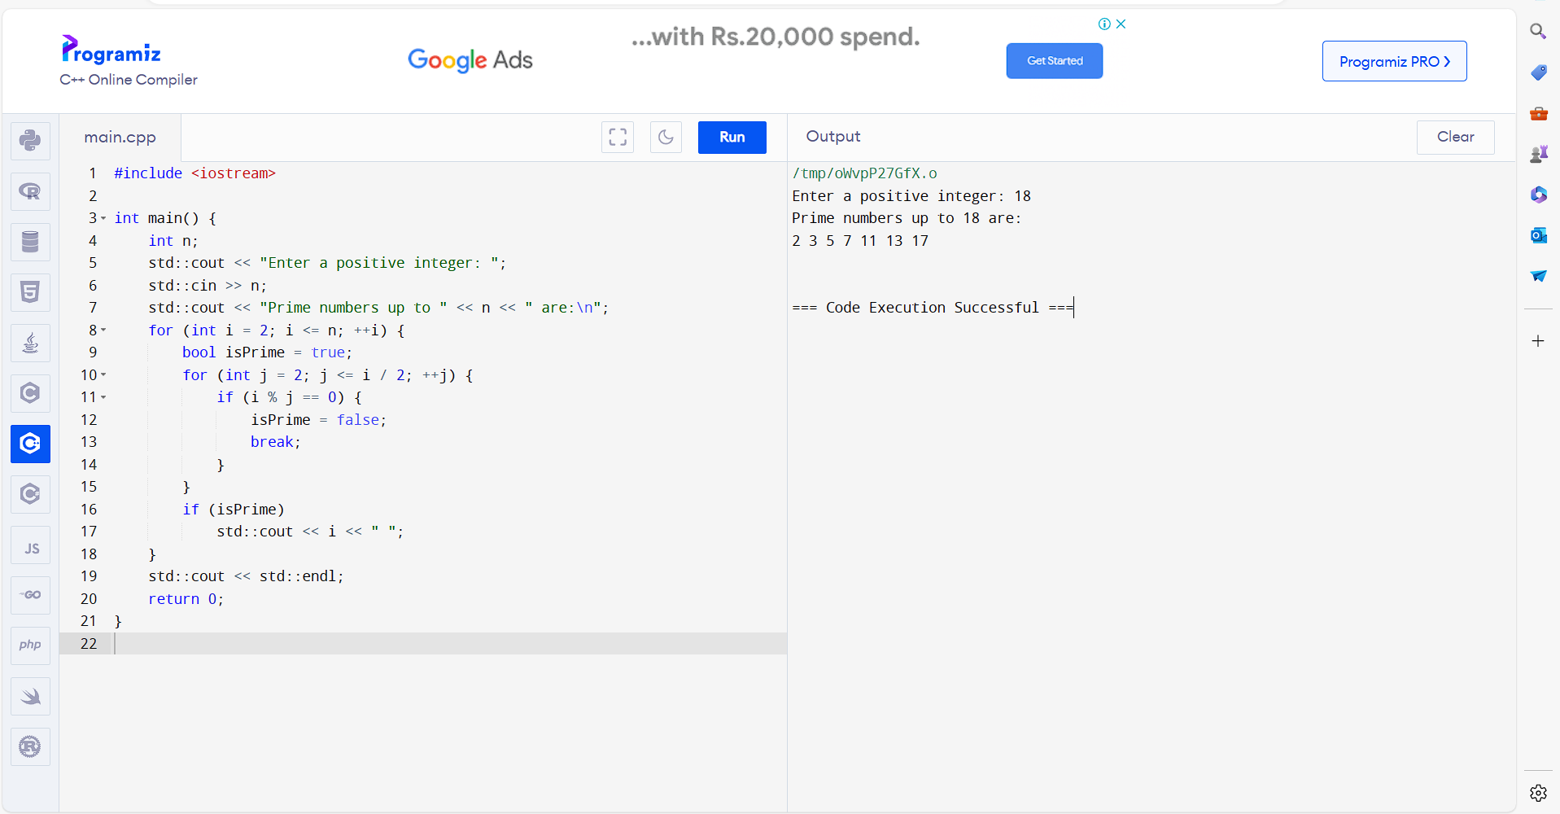

37. Write a C++ Program to Calculate Power of a Number

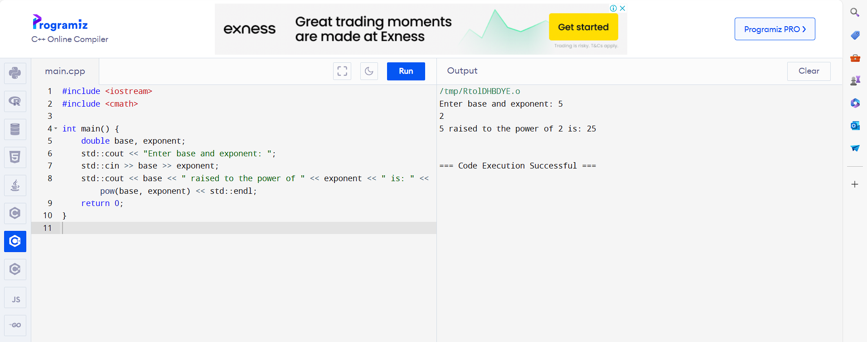

38. Write a C++ Program to Increment ++ and Decrement -- Operator Overloading in

C++ Programming

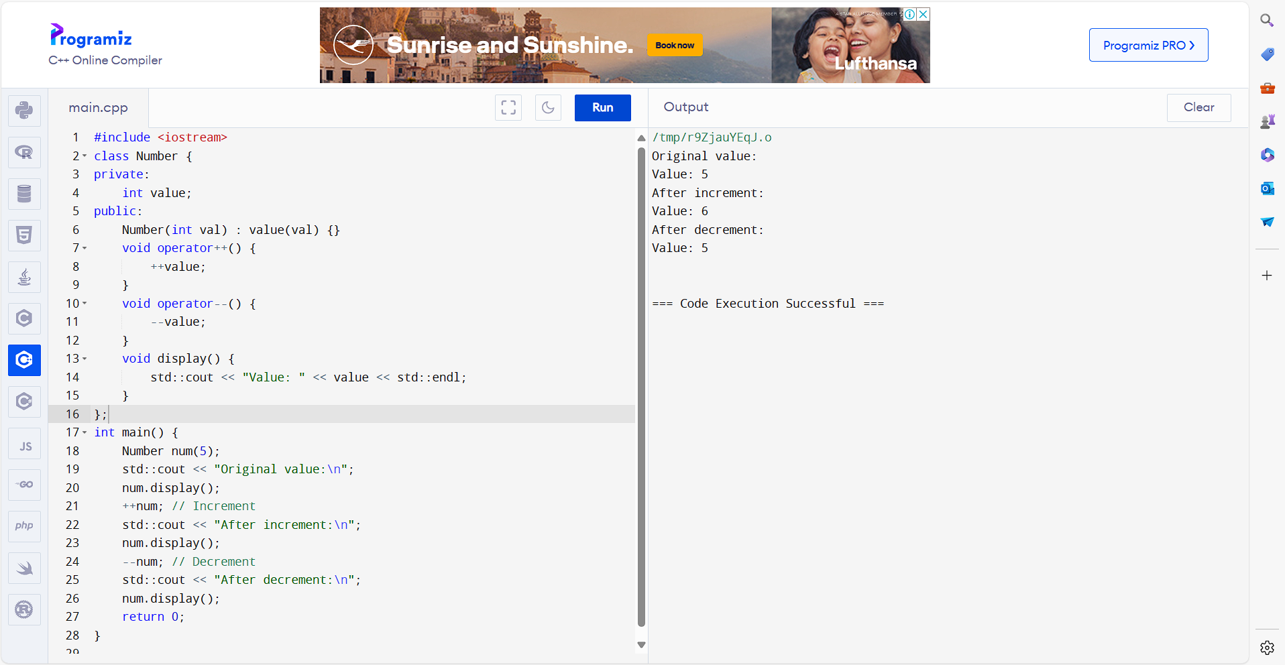

39. Write a C++ Program to Subtract Complex Number Using Operator Overloading

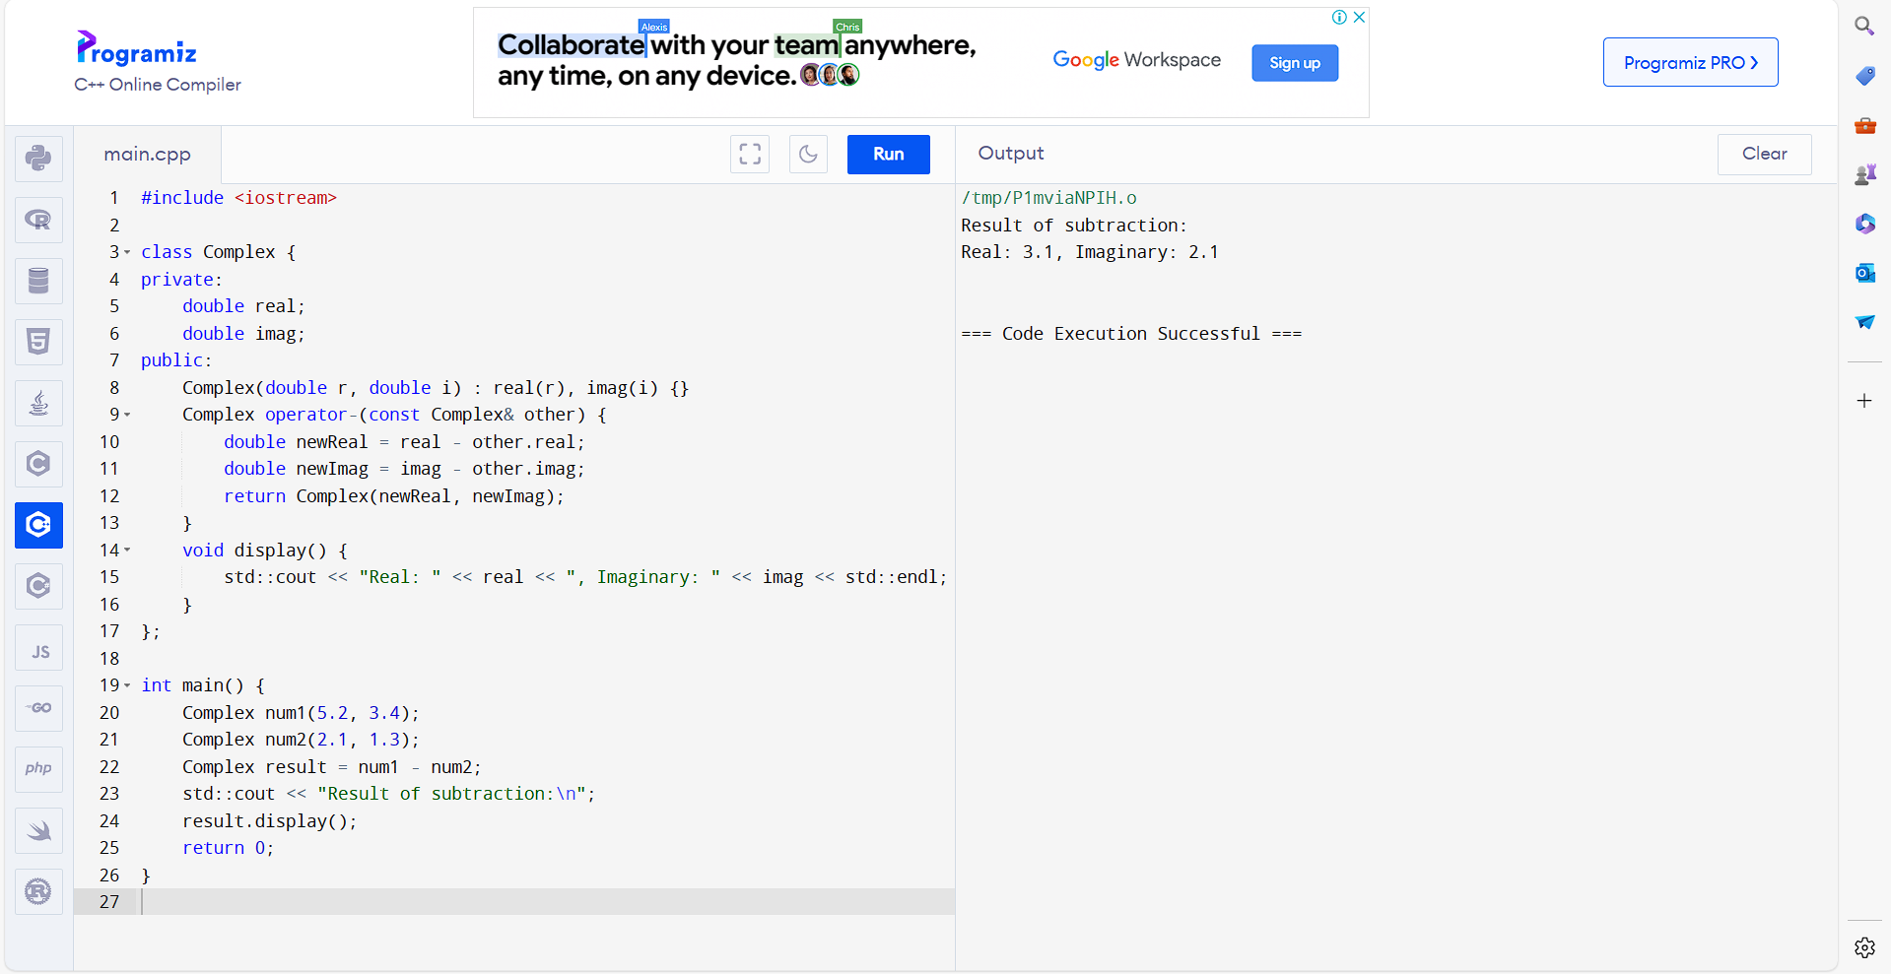

40. Write a C++ Program to Find ASCII Value of a Character

